**PRACTICE REPORT**

**Subject: Web application**

**Lab 5: Build React App**

*Instructor: Trần Vĩnh Khiêm*

*Report date: 30/12/2023*

1. **GENERAL INFORMATION:**

Class: MSIS207.O12.CTTT.1

|  |  |  |  |
| --- | --- | --- | --- |
| **No** | **Name** | **Student ID** | **Email** |
| 1 | Nguyễn Văn Trường Khoa | 20521472 | [20521472@gm.uit.edu.vn](mailto:20521472@gm.uit.edu.vn) |
| 2 |  |  |  |

## DETAILED REPORT

**Link Github contain code:**

<https://github.com/KRocker3512/Web-app-practice-class>

**Note** : If you can’t access link above, please contact to me via email :20521472@gm.uit.edu.vn .

1. **Exercise 0**

**React 3:**

Demo:

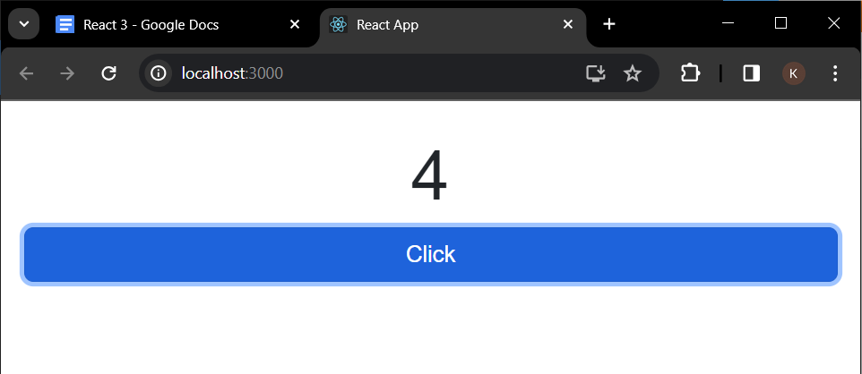

Code:

App.js

|  |
| --- |
| import Button from "react-bootstrap/Button";  import React, { useState } from "react";  import "./style.scss";  const React3 = () => {    const [counter, setCounter] = useState(0);    const increaseCounter = () => {      setCounter(counter + 1);    };    return (      <div class="react3">        <div className="result">{counter}</div>        <Button onClick={increaseCounter} size="lg">          Click        </Button>      </div>    );  };  export default React3; |

SCSS:

|  |
| --- |
| .react3 {    display: flex;    justify-content: center;    padding: 20px;    flex-direction: column;    .result {      font-size: 60px;      text-align: center;    }  } |

**React 6:**

Demo:

Code:

Index.js

|  |
| --- |
| import MyComponent from "./components/myComponent";  import { ThemeProvider } from "./ThemeContext";  const React6 = () => {    return (      <ThemeProvider>        <MyComponent />      </ThemeProvider>    );  };  export default React6; |

ThemeContext.js

|  |
| --- |
| import React, { createContext, useEffect, useState } from "react";  const ThemeContext = createContext();  const ThemeProvider = (props) => {    const { children } = props;    const [theme, setTheme] = useState(false);    const toggleTheme = () => {      if (theme) document.documentElement.dataset.theme = "light";      else document.documentElement.dataset.theme = "dark";      setTheme((prev) => !prev);    };    useEffect(() => {      document.documentElement.dataset.theme = "light";    }, []);    const value = { theme, toggleTheme };    return (      <ThemeContext.Provider value={value}>{children}</ThemeContext.Provider>    );  };  export { ThemeContext, ThemeProvider }; |

Iteam component:

JS

|  |
| --- |
| import React, { useContext } from "react";  import "./style.scss";  import { ThemeContext } from "react6/ThemeContext";  const Item = (props) => {    const context = useContext(ThemeContext);    console.log(context);    const { title, content } = props;    return (      <div className="component-item">        <div className="title">{title}</div>        <div className="content">{content}</div>      </div>    );  };  export default Item; |

Scss

|  |
| --- |
| .component-item {    display: flex;    margin: 10px;    .title,    .content {      padding: 10px;      border: 5px solid;    }    .title {      width: 200px;      border-color: red;    }    .content {      width: calc(100% - 200px);      border-color: blue;    }  } |

myComponent component:

JS

|  |
| --- |
| import React, { useContext } from "react";  import { ThemeContext } from "../../ThemeContext";  import "./style.scss";  const MyComponent = () => {    const context = useContext(ThemeContext);    return (      <div className="my-component">        <div className="title">title</div>        <button onClick={context.toggleTheme}>Click</button>      </div>    );  };  export default MyComponent; |

SCSS

|  |
| --- |
| .my-component {    height: 100vh;    background-color: var(--bg-main);    .title {      padding: 10px;      font-size: 40px;      color: var(--txt1);    }  } |

1. **Exercise 1**
2. **Exercise 2**

Demo :

Code : Because the code is too much and too long, I don't show it in the doc file but put it on github